INTRODUCTION

* 1. Overview

**Retail management refers to the process of helping customers find products in your store.it includes everything from increasing your customer pool to how products are presented , and how you fulfil a customer’s needs. customer pool to how products are presented, and how you fulfil a customer how products are presented , and how you fulfil a customer’s needs.**

**Sales force**

**Salesforce is your customer success platform, designed to help you sell,service,market,analyze and connect with your customer**

**Objects:**

**Objects are database tables that permit you to store data that is specific to an organisation. Salesforce objects are two types**

**1.standard objects        2.custom objects**

**Relation between the objects:**

**Object relationship are special field types that connect two objects .as crm product owner create relationship to link objects with each other, so that when uses view records ,they can also see related data**

**Application :**

**Apps in salesforce are a group of tabs that help the application function by working together as a unit . It has a name , a logo and a particular an app is a collection of items that work together to serve a particular function .salesforce apps come in two flavors : classic and lighting**

**Layouts :**

**Page layouts control the layout of an objects.**

**Users:**

**A user is anyone who logs in salesforce . Users are employees at your company.**

**Validation rule :**

**Validation rule is verify the data users .**

**Reports:**

**A report is a list of records that meet the criteria your define . It's displayed in salesforce in rows and columns and can filtered, grouped or displayed in a graphical chart.every report is stored in a folder.**

**Dashboard:**

**Dashboards is salesforce are a graphical representation of reports.**

* 1. Purpose
* **Retail management** improves overall company cohesion.
* **Retail store management** improves customer experience and boosts customer satisfaction.
* **Retail operation management** contributes to business growth.

Problem Definition & Design Thinking

2.1 Empathy Map

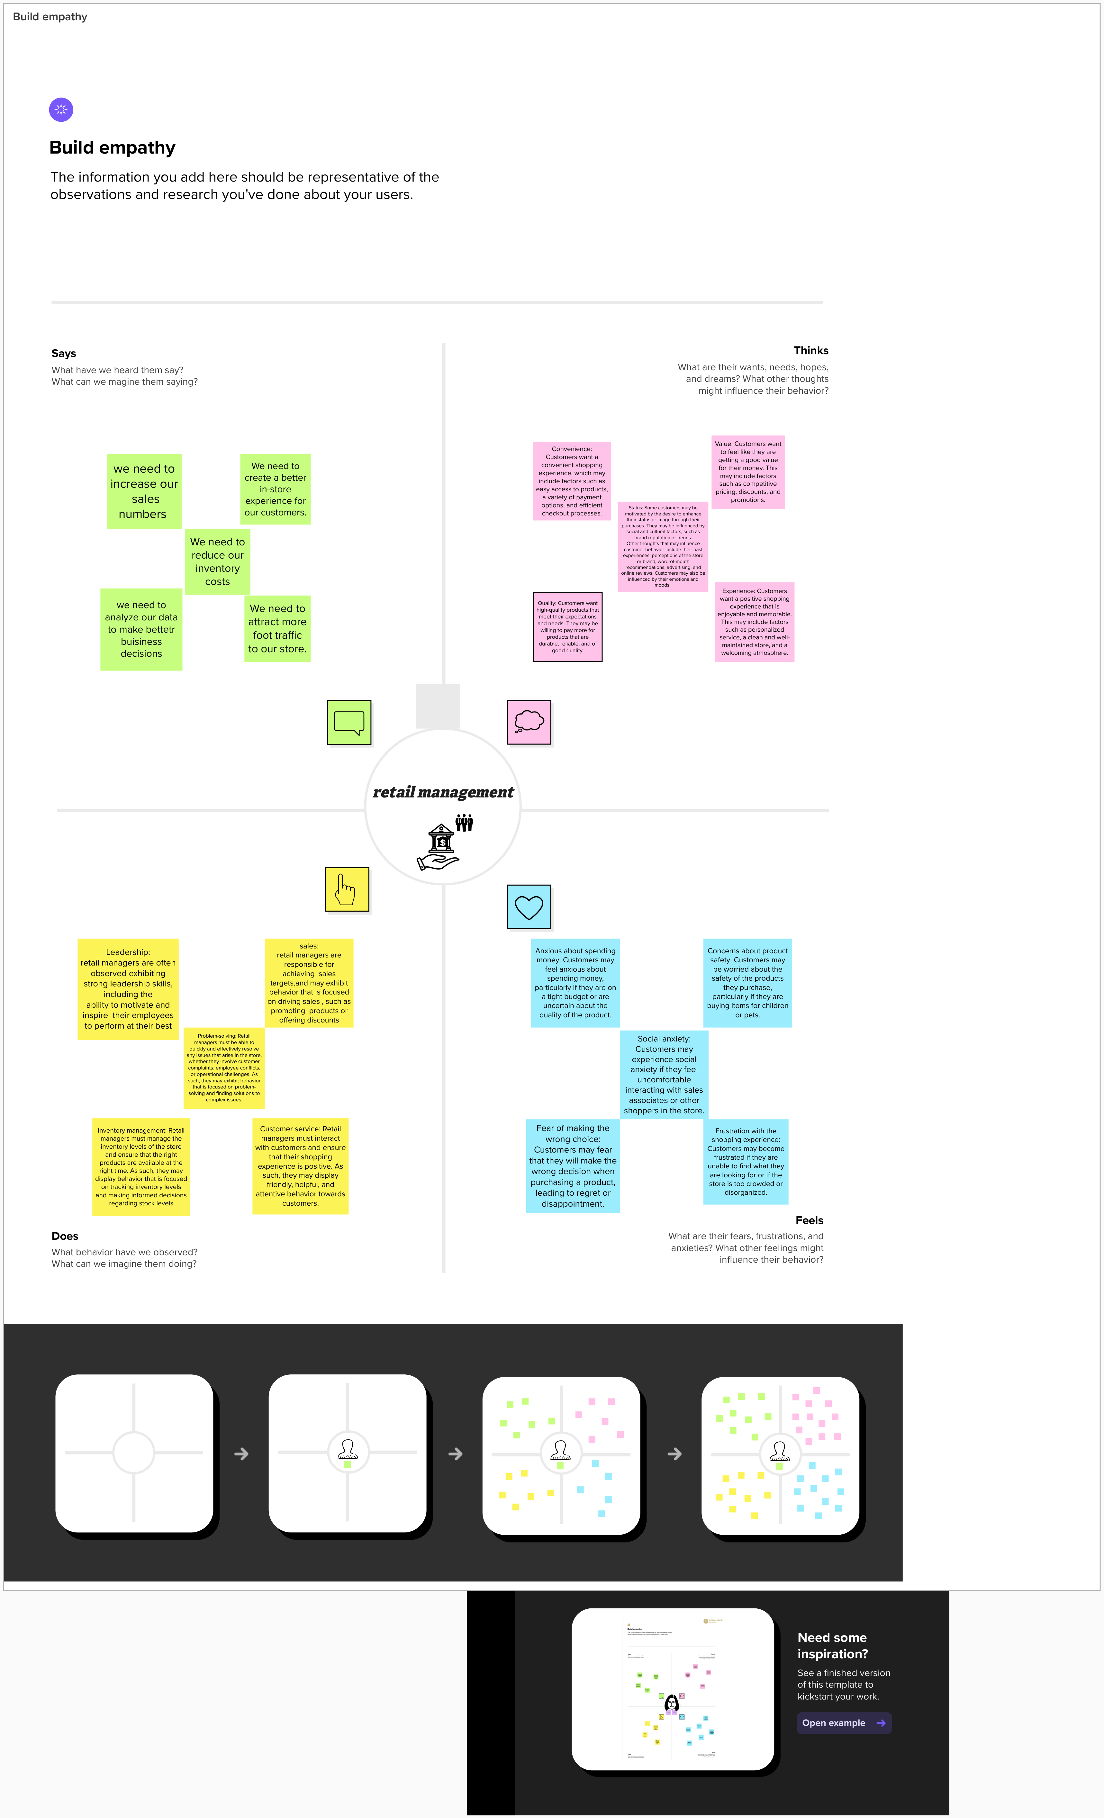

2.2 Ideation & Brainstorming Map



RESULT

3.1 Data Model

| Object name | Fields in the Object |
| --- | --- |
| Obj 1 | | Field Label | Data type | | --- | --- | | warehouse | master detail(warehouse) | |
| Obj 2 | | product | master detail(product) | | --- | --- | | stock | checkbox | |
| Obj 3 | | sales order | master detail(sales order) | | --- | --- | | dispatch tracking | master detail | |
| Obj 4 | | Field Label | Data type | | --- | --- | | accounts | text | |

3.2 Activity & Screenshot

**custom object:**

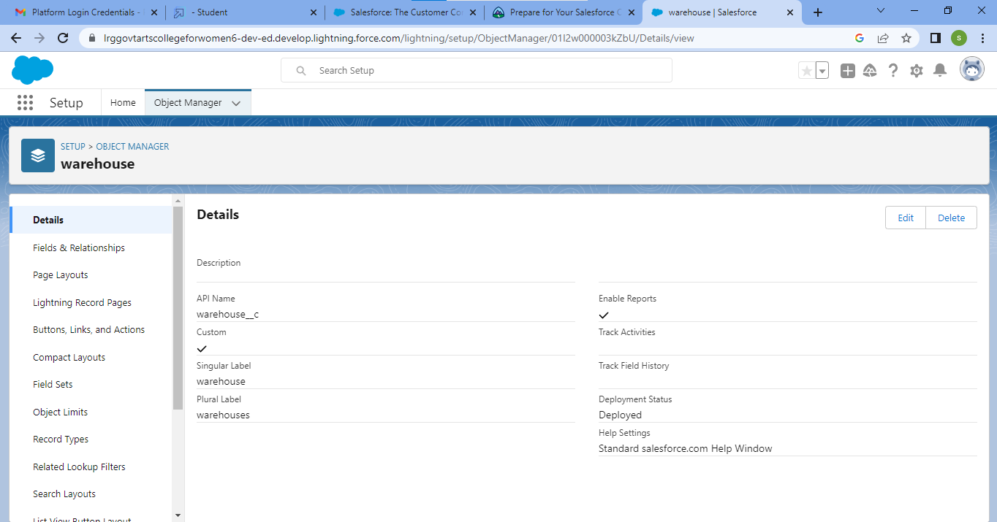

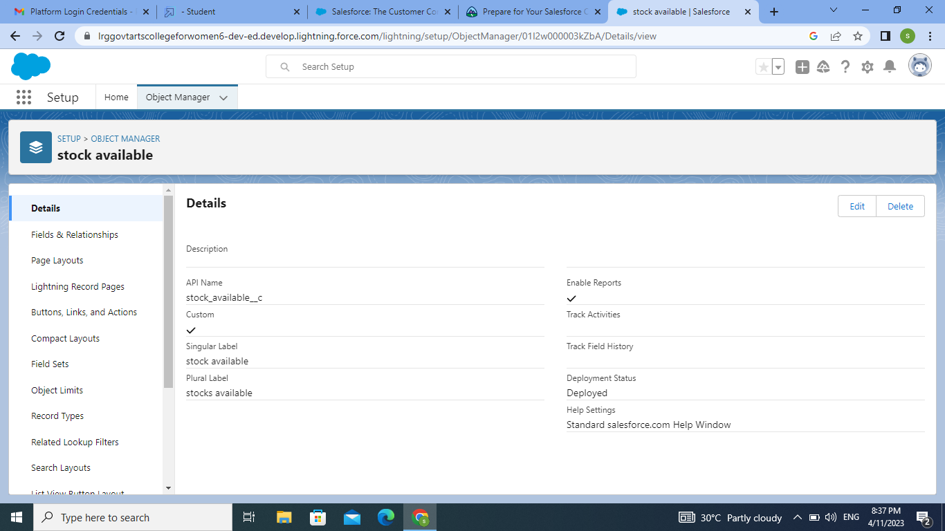

**tabs:**

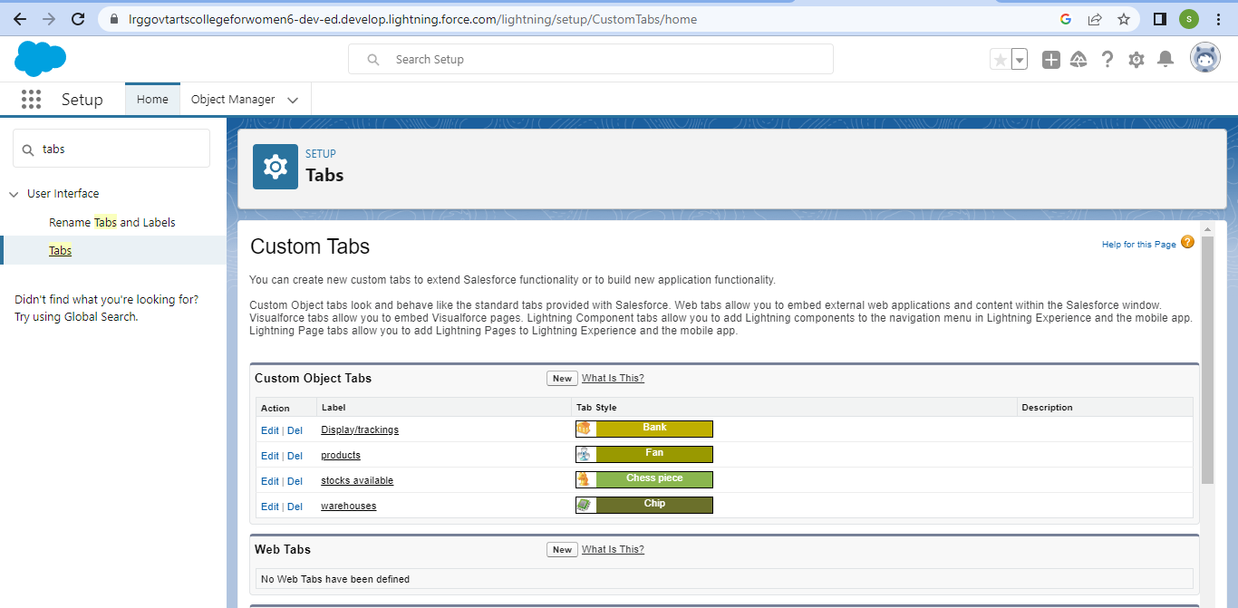

**relation between objects:**

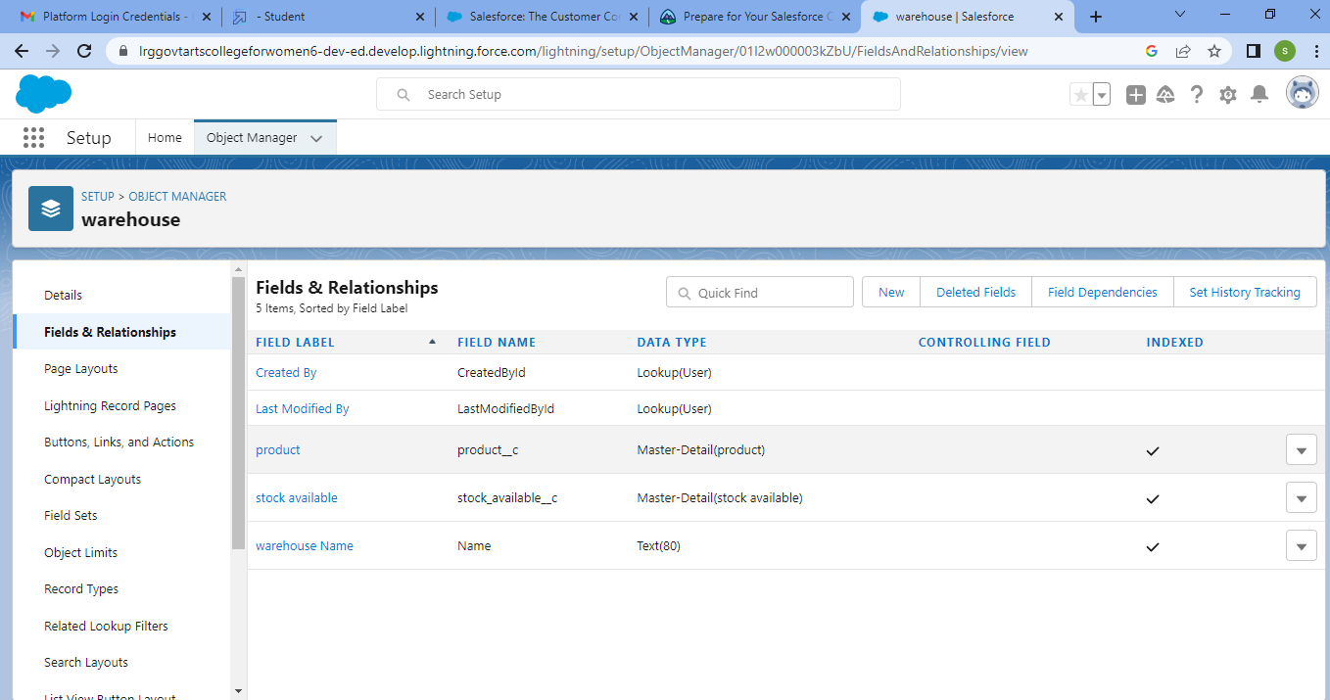

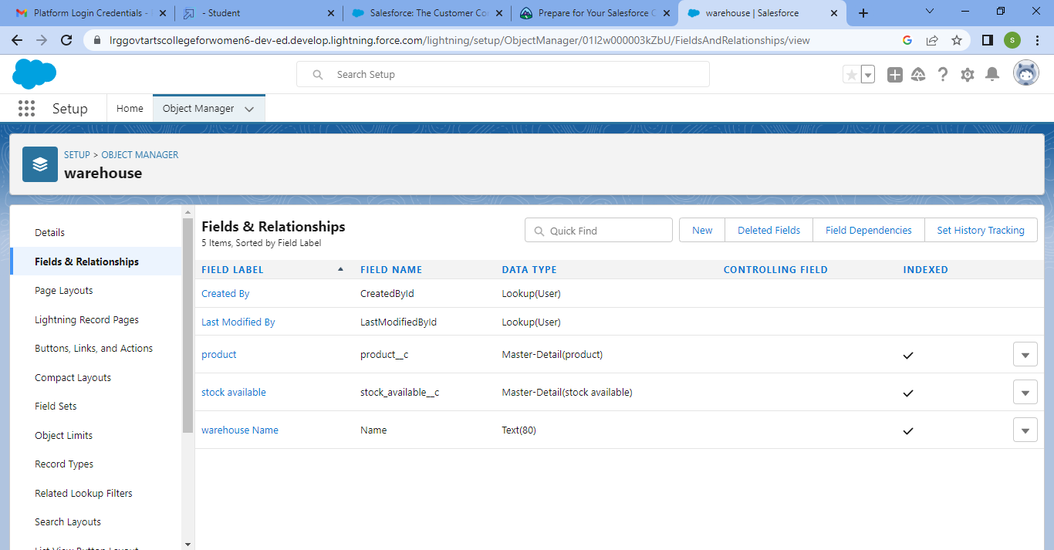

**application:**

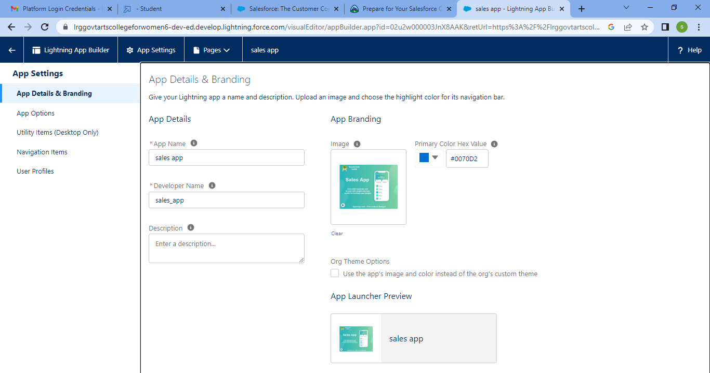

**layouts:**



**users:**

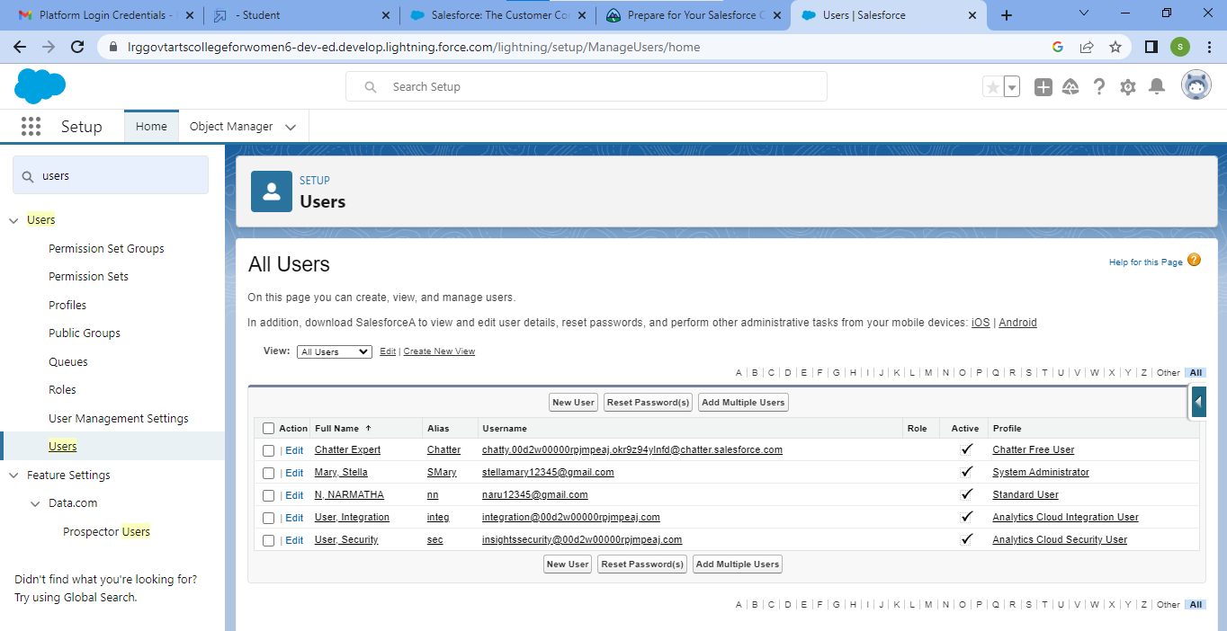

**validation rule:**

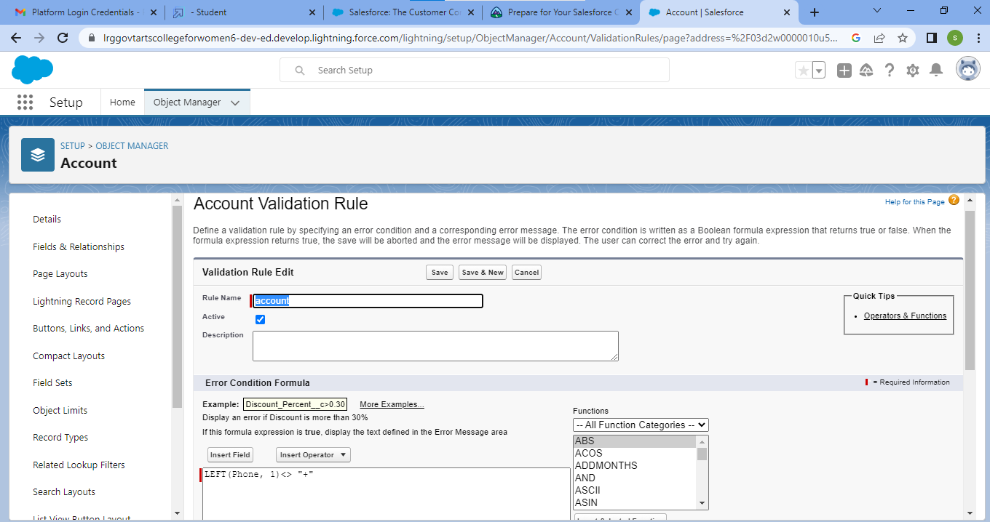

**formula**

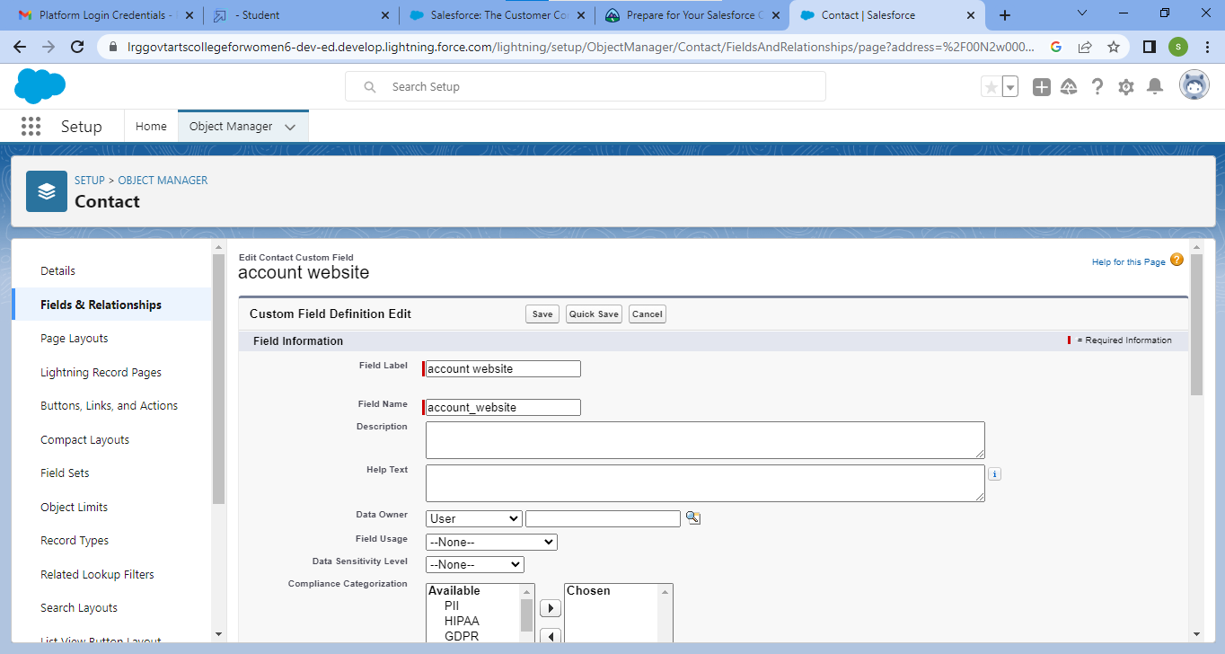

**reports:**

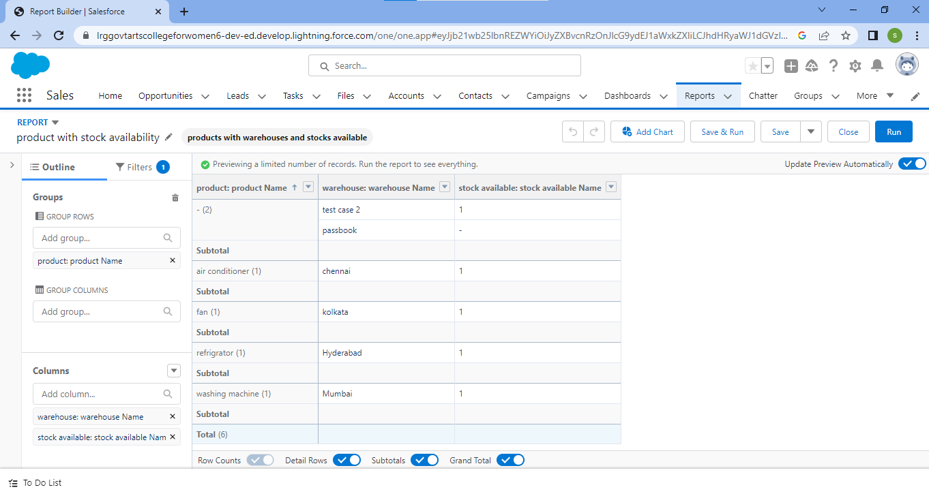

**dashboards:**

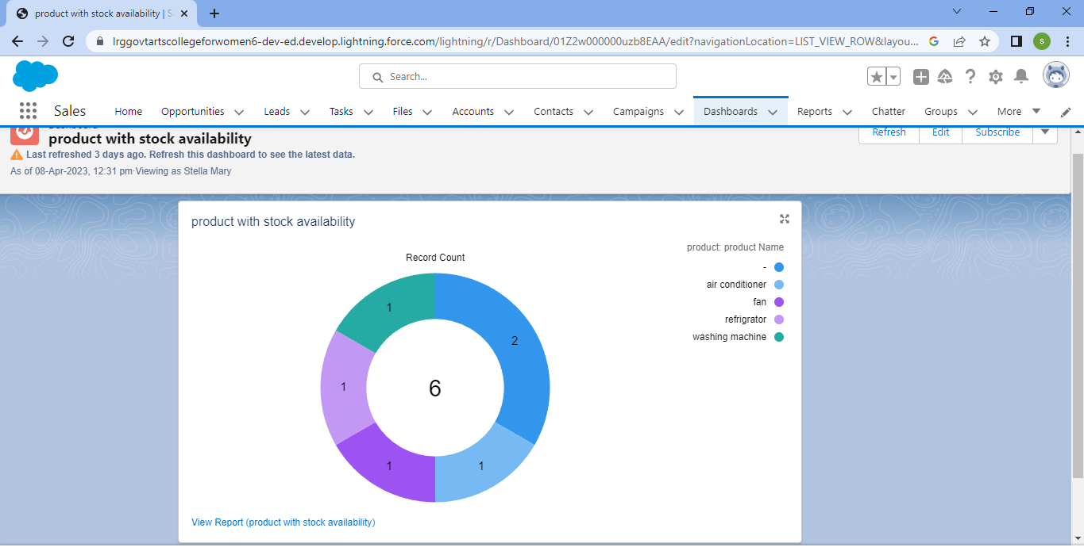

Trailhead Profile Public URL

Team Lead – https://trailblazer.me/id/smary48

Team Member 1 –https://trailblazer.me/id/narmatha1

Team Member 2 –https://trailblazer.me/id/rhari134

Team Member 3 –https://trailblazer.me/id/tharanya123

Team Member 4 –https://trailblazer.me/id/pelango12

ADVANTAGES & DISADVANDAGE

ADVANTAGES:

* sales processes and make them more efficient.
* With Salesforce, you can keep track of your customers’ movements and interactions in a centralized location.
* Salesforce allows you to customize the platform to suit your specific needs.
* Creating a sustainable competitive advantage

DISADVANTAGES:.

* You have to pay for add-ons to get the most out of the software.
* Configuration and setup is complex and time-consuming.
* Cluttered interface makes navigation and simple tasks unnecessarily complex.
* The learning curve never seems to end.
* Customer support has a poor reputation
* Expensive.

APPLICATIONS

* Buying
* Pricing
* Merchandising
* Marketing
* Personnel
* Customer service
* Training
* Operations

CONCLUSION

FUTURE SCOPE

* Retail Manager
* Store Manager
* Retail Buyer
* Warehouse Manager
* Brand Manager
* Customer Care Executives
* Image Promoter
* Merchandise Manager
* Merchandiser Analys